
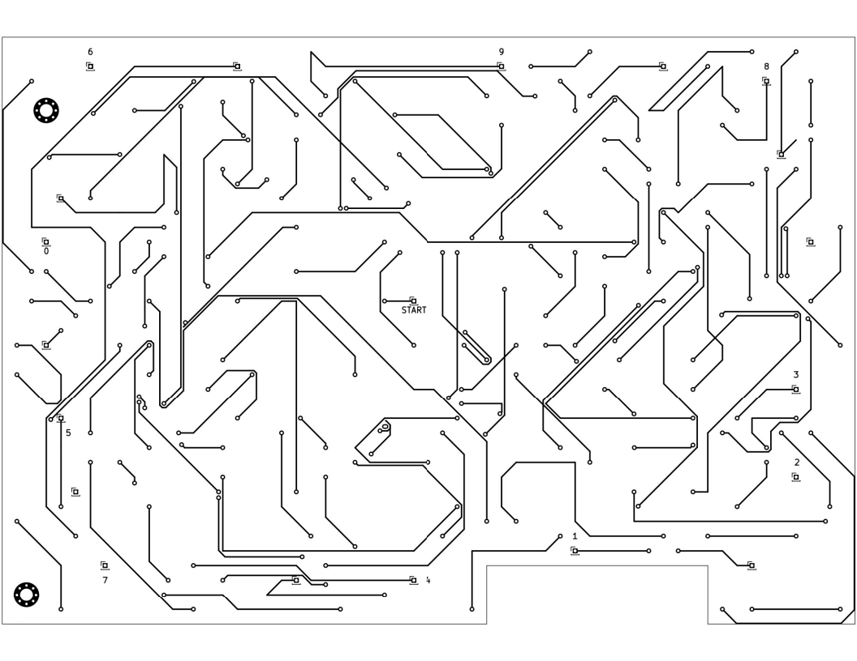
= a connection to the other side

___ ___ ___ ___ ___ ___ ___ ___
